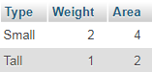

Figure : Table of Minions

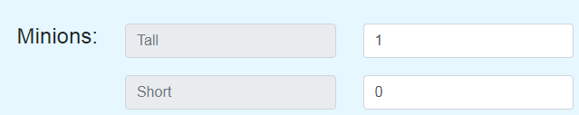

Figure : Test 1 - 1 Tall Minion, 0 Short Minions

**Test 1** – 1 Tall Minion, 0 Short Minions. Result should be: 1 cargo, weight of 1, area of 2.

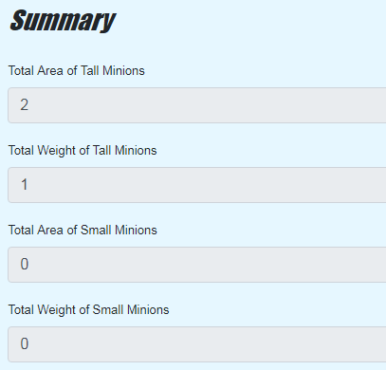

Figure : Test 1 Summary

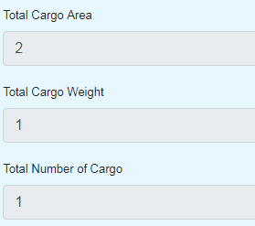

Figure : Test 1 Result

Test passed.

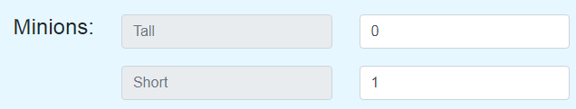

Figure : Test 2 - 1 Short Minion, 0 Tall Minions

**Test 2** – result should be 1 cargo, weight of 2, area of 4.

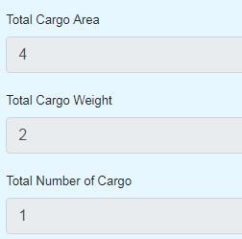

Figure : Test 2 Result

Test passed.

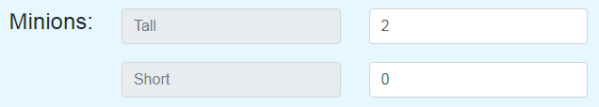

Figure : Test 3 - 2 Tall Minions, 0 Short Minions

**Test 3** – expected result cargo of 2, weight of 2, area of 4.

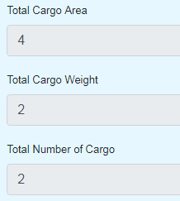

Figure : Test 3 Result

Test passed

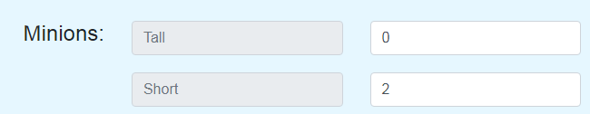

Figure : Test 4 - 2 short minions, 0 tall minions

**Test 4** – expected result cargo of 2, weight of 4, area of 8.

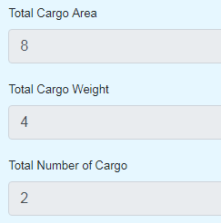

Figure : Test 4 Result

Test passed

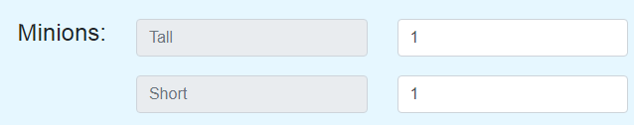

Figure : Test 5 - 1 Tall Minion, 1 Short Minion

**Test 5** – expected result cargo of 2, weight of 3, area of 6.

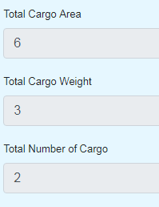

Figure : Test 5 Result

Test Passed.